Original Article
Click here to enter the title of your manuscript
Ecrire le titre de l’article

First author¹, Second author ², Third author ¹
¹ Full Address
² Full Address
Ab s t r a c t:
Click here to enter your abstract. The unstructured abstract does not exceed 300 words.
Keywords: keyword 1, keyword 2, keyword 3, keyword 4, keyword 5 (no more than 5 keywords)

Résumé
Cliquez ici pour introduire votre résumé. Le résumé non structuré n’excède pas 300 mots.
Mots Clés: Mot clé 1, Mot clé 2, Mot clé 3, Mot clé 4, Mot clé 5 (maximum 05 Mots clés)

* Corresponding author. Tel.: ; fax: +0-000-000-0000.
E-mailAddress: auteur@gmail.com
Received on:
Revised on:
Accepted on:

Introduction
The introduction should briefly present the study in a broad context and explain why it is important. The purpose of the work and its importance should be defined. The current state of the research field needs to be carefully considered and the main publications cited. Please highlight controversial and divergent assumptions when necessary. Finally, mention the main purpose of the work and highlight the main conclusions. Whenever possible, ensure that the introduction is understandable to scientists outside your area of ​​research.
The manuscript should not exceed 4 500 words, 04 figures and/or tables, and 45 references.
References must be numbered in the order of appearance and indicated by one or more numbers in square brackets, for example, [1] or [2,3] or [4-6]. Please go down to the end of this document for more details on references.
Material and Methods
This section should be described in sufficient detail to allow reproduction and reliance on published results. Please note that the publication of your manuscript implies that you must make all materials, data, computer codes and protocols associated with the publication available to readers. Please disclose at the submission stage any restrictions on the availability of material or information. New methods and protocols need to be described in detail, while well-established methods can be briefly described and appropriately cited.
Intervention studies involving animals or humans, and other studies requiring ethical approval, should list the authority that provided the approval and the corresponding ethical approval code.

Results
This section can be divided into subtitles. It should provide a concise and precise description of the experimental results, their interpretation and the experimental conclusions that can be drawn.
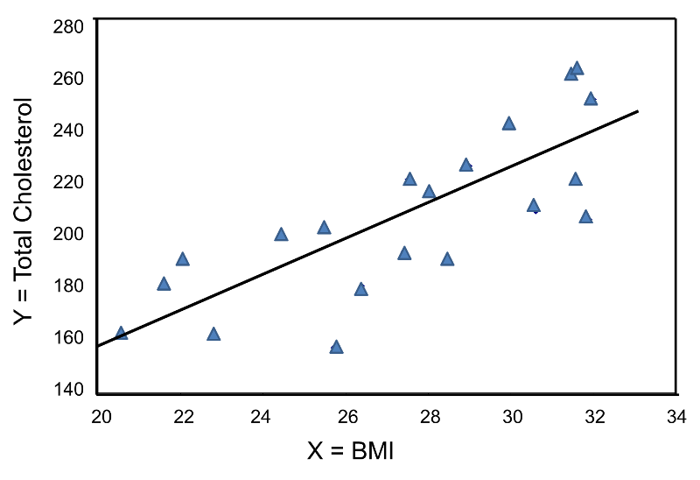
All figures and tables should be quoted in the main text as Figure 1, Table 1, etc.

Figure 1: Title of figure 1

This is a figure; the diagrams follow the same formatting. If there are multiple panels, they should be listed as follows: (a) Description of what is contained in the first panel; (b) Description of what is contained in the second panel. Figures should be placed in the main text near the first time they are cited. A single line legend must be centered.
Discussion
Authors should discuss the results and how they can be interpreted from the perspective of previous studies and working hypotheses. The results and their implications should be discussed in the broadest possible context. Future research areas can also be highlighted.
Limitations of the study should be mentioned at the end of this section.

Conclusion
This section should highlight the important findings of the study.
Conflicts of interest
Declare conflicts of interest or state "Authors do not declare any conflict of interest". Authors must identify and report any situation or personal interest that may be perceived as inappropriately influencing the representation or interpretation of the reported research findings. Any role of the funders in the design of the study; in the collection, analysis or interpretation of data; in writing the manuscript, or in the decision to publish the results must be declared in this section. If there is no role, please indicate "Donors have not played a role in the design of the study; in the collection, analysis or interpretation of data; in writing the manuscript or in the decision to publish the results ".
Acknowledgments
This section is not mandatory, but can be added to the manuscript.
In this section you can thanks any support provided that is not covered by the author's contribution or funding sections. This may include administrative and technical support, or in-kind donations (for example, equipment used for experiments).

Funding

Please add: "This research did not receive any external funding" or "This research was funded by NAME OF FUNDING, Grant # XXX" and. Check carefully that the information provided is accurate and use the standard spelling of funding agency names at https://search.crossref.org/funding. Any mistake can affect your future funding.
References
References should be numbered in order of appearance in the text (including citations in tables and captions) and listed individually at the end of the manuscript. We recommend that you prepare references with bibliography software, such as EndNote, Reference Manager, or Zotero, to avoid typing errors and duplicate references. Include the Digital Object Identifier (DOI) for all references, if any.
In the text, reference numbers must be enclosed in square brackets [] and before punctuation; for example [1], [1-3] or [1,3].
- For scientific articles: Author 1, A.B.; Author 2, C.D (year) Title of the article. Short name of journal, Volume, pp
- For book chapter: Author 1, A.B.; Author 2, C.D. Title of the chapter. In Book title, 2^{nd e}d.; Editor 1, A., Editor 2, B., Eds.; Editor: Publisher Location, Country, year; Volume , p.p.
- For books: Author 1, A.B.; Author 2, C.D. Book title. 3rd Ed.; Editor: Publisher Location, Country, year; pp.
- For unpublished work (pre-print): Author 1, A.B.; Author 2, C. Title of the unpublished work. Name of the abridged journal stage of the publication (under revision, accepted, in press).
- For personal communication: Author 1, A.B. (University, city, state, country); Author 2, C. (Institute, City, State, Country). Personal communication, year.
- For presentations published on acts: Author 1, A.B.; Author 2, C.D.; Author 3, E.F. Title of the presentation. Title of the combined work (if available), Acts of the name of the conference, place of the conference, country, date of the conference; Publisher 1, Publisher 2, Eds. (If available); Publisher: City, Country, Year (if available); Abstract number (optional), pagination (optional).
- For thesis: Author 1, A.B. Title of the thesis. Thesis level, University giving the degree, Location of the university, Completion date.
- For web sites: Title of the site. Available online: URL (consulted on the day month year).

